Sardar Patel Institute of Technology,Mumbai

**Department of Computer Science Engineering**

**B.E. Sem-VII- PE-IV (2024-2025)**

**IT 24 - AI in Healthcare**

**Experiment 7: Healthcare data analysis using Tableau**

**Name:** Adwait Purao UID: 2021300101 **Date:** 28/10/2024

**Objective:** To analyze the distribution of treatment outcomes across different Treatment types, cost analysis for the treatment and create a dashboard.

**Steps:**

1. **Create a New Worksheet**
2. **Drag Fields to the View**
3. **Visualize using various graphical representations.**
   1. How many patients have each outcome (e.g., Recovered, Not Recovered, Deceased) for different types of treatments (e.g., Surgery, Medication)
   2. cost analysis for hospital stay.
4. **Creating a Dashboard**

**Output:**

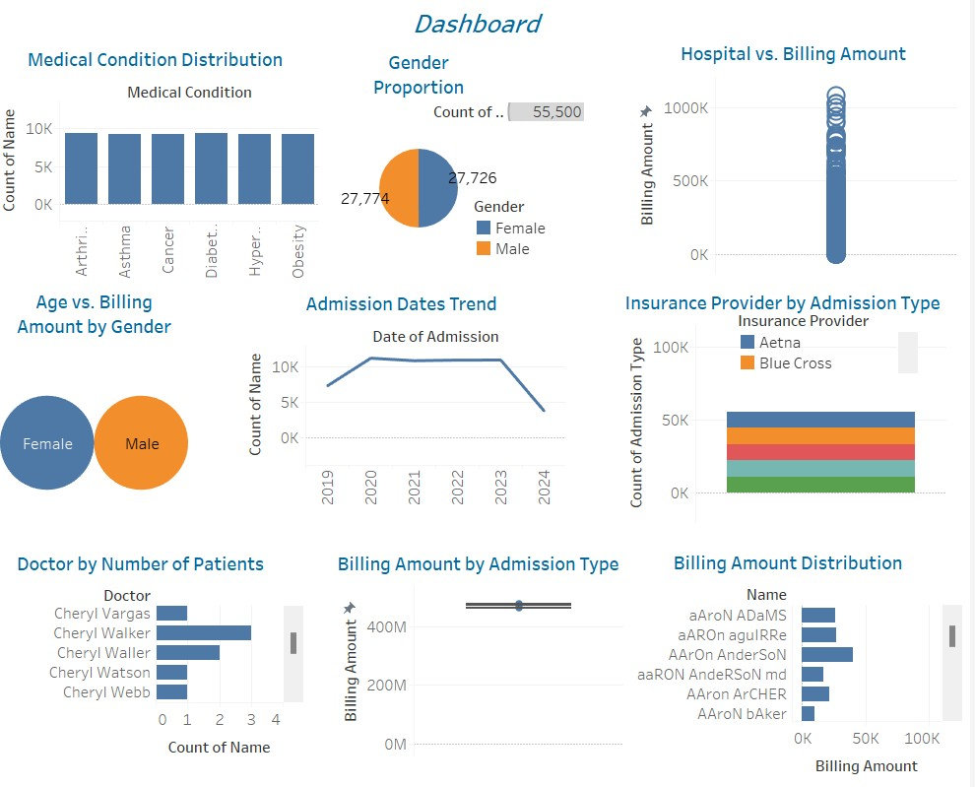

**CONCLUSION:**

* The facility serves a perfectly balanced patient demographic with approximately

27,774 patients each for both males and females (total 55,500 patients), suggesting equitable healthcare access across genders.

* There are six major medical conditions (Arthritis, Asthma, Cancer, Diabetes,

Hypertension, and Obesity) with remarkably similar prevalence rates of around 8-9K cases each, indicating the facility needs to maintain equal resources and expertise across these conditions.

* The admission trend shows a distinct peak during 2021-2022 followed by a sharp decline towards 2024, which could be correlated with COVID-19 impact or changes in healthcare delivery models.
* The facility's billing amounts show significant variation, ranging from 0K to

approximately 100K per patient, with multiple insurance providers (including Aetna and Blue Cross) handling the coverage.

* The doctor-patient distribution shows varying patient loads among physicians (all named Cheryl), with some handling significantly more patients than others, suggesting potential opportunities for workload balancing.